**Appraisal of the Three Major Development Scenarios of the Polish Railway Network**



**Submitted by: Jan Kiljański**

**629739**

**31-08-2024**

**Abstract**

*This article analyzes the economic impact of three different considered scenarios of the planned infrastructural investment in the Polish railway network. It uses a general equilibrium spatial model introduced by Monte et al. (2018) to asses the economic impacts of the diminished travel time on economic activity, housing market and population movement on the level of counties (Powiaty). It compares three different scenarios to the case of resignation from major infrastructural investments, 1) construction of so called “Y-line” highspeed train, and 2) development of a wholly new, huge net of highspeed trains (so called “szprychy”/”spokes”) that constituted the core of the 2016 proposal of the PIS government, 3) development of an alternative project announced in the spring of 2024 by the ruling coalition after their comeback to power. This model belongs to the new class of transport investments appraisal within general equilibrium framework, that present a significant progress over two previous appraisal approaches. It allows for dynamic adjustments, improving on the previous static partial equilibrium models. It allows for broad assessment of economic impact of investments, significantly contributing to the Polish public debate on the topic. It adds another highly relevant dimension to impact considerations limited to analysis in bare accessibility arguments, that dominate in the Polish media.*

GitHub

*The whole code used for the generation of the outcomes in the presented article can be viewed in the GitHub repository*

<https://github.com/jjkiljanski/Central-Communication-Port-Appraisal.git>

Total number of Words: 4218

+ around 900 words of Counterfactuals code in GitHub repository

+ 500 words of GitHub repository Readme

(please, count if needed)

1. **Introduction**

Since the fall of the Communist Regime in 1989, Poland has been the quickest developing economy in Europe and one of the quickest developing economies in the world. It quickly appeared obvious that to sustain the development a massive investment in new transport infrastructure is needed. In the beginning of the XXI century, the total length of the Polish highways was not bigger than several hundreds of kilometers, and the dramatic state of road infrastructure the abrubt construction of almost 4500 km of new highways in the first quarter of the XXI century.

At the same time, the rail infrastructure development mostly stagnated, or was at least much slower. The breakthrough came in 2016, when the ruling Law and Justice party (Prawo i Sprawiedliwość, PIS) announced the planned construction of a gigantic airport hub in the center of Poland: Central Communication Port (Centralny Port Komunikacyjny, CPK). It was supposed to emerge as the biggest airport in Central-Eastern Europe and a major hub for flights between Europe and Asia.

The construction of airport was aimed to be accompanied by a dramatic intervention in the existent railway network. The airport (located to the West-South of Warsaw, in a distant, sparsely populated area), was supposed to emerge as the center of a new system of highspeed railways spreading outwards like rays in all directions.

The project quickly came forth as one of the most prominent topics in the Polish public debate. On the one hand, the need of significant impulse to the development of railways was widely acknowledged. On the other, the project was criticized due to the necessity of construction of a whole new network of railways, independent of the (underdeveloped, but extensive) existent ones. The surprising form of rays spreading from the CPK didn’t seem to solve many problems of connectivity between cities located further from the center of Poland.

After a short time of uncertainty after the change of the government in Poland in the end of 2023, the previous opposition announced that the project of the construction of CPK will be continued, but in a different form. The structure of “spokes” around CPK is supposed to be replaced by a *network* of highspeed trains connecting the bigger Polish cities. The highest speed on some components of the railway is supposed to reach 350 instead of 300 km/h. I refer to the project as the KO (Koalicja Obywatelska, the Citizen Coalition – the biggest of three ruling parties in Poland) project below.

Though the future fate of the whole project seems not fully decided, one part of the project, so called “Y-line” highspeed train connecting Poznan, Wroclaw, and Warsaw, will most probably be constructed in the coming years. The part is a common denominator of both the PIS, and the new government’s project, and its construction seems surrounded by a much broader public support.

Despite the high controversies evoked by the project, the debate still lacks systematic quantitative arguments about the expected economic impacts of the project. In the following article, I decided to use a spatial general equilibrium model introduced by Monte et al. (2018) in order to assess the impacts of three possible future developments of the Polish railway infrastructure in the oncoming future, on the economic activity, population movements, and the housing market in Poland. I use the Monte et al. (2018) model out of two reasons.

Firstly, the Polish public debate on the topic is heavily dominated by analyses in terms of passenger flows, accessibility improvements etc. Some models present very elaborate and heavily quantitative assessments in these dimensions (cp. especially Integrated Traffic Model/Zintegrowany Model Ruchu, or Passenger Transport Model/Pasażerski Model Transportowy). Nevertheless, these considerations lack any deep integration of economic mechanisms that constitute a major underlying force governing the movements in the society. The Monte et al. (2018) model integrates transport flows and economic outcomes into one, unified framework.

Secondly, the Monte et al. (2018) model constitutes a significant improvement over the previous standards of infrastructural appraisal within the partial equilibrium framework. The unique solution of the model equations allows for the estimation of counterfactuals, after the recovery of the productivity and amenity fundamentals of the considered spatial units.

*Figure 1. Schema of the Y-Line on the background of the future railway network.*

*Figure 2. Schema of the PIS “Spokes” on the background of the future railway network.*

*Figure 3. Schema of the KO project on the background of the future railway network.*

The rest of the article proceeds as follows. In the section II, I describe the model components shortly. In the section III, I describe the data sources and processing. In the section IV, I describe impacts of the different scenarios of the development of the Polish railway network.

1. **The Model**

The Monte et al. (2018) model is a general equilibrium model with unique solution, which allows for the estimation of counterfactuals. The complexity of equations constituting the model make it necessary to solve the model numerically. In the process of preparation of the following article, I decided to use the Gabriel Ahlfeldt’s and Tobias Seidel’s (2024) implementation of a slightly modified version of the model available on GitHub.

I present a very brief and selective summary of the model, introducing only the components essential for the understanding of the presented outcomes.

On the individual’s side, every person maximalizes utility connected with living and consuming in place $n$, and working in place $i$ defined according to the equation:

$$U_{niω}= \frac{b_{niω}}{κ_{ni}}{\left(\frac{C_{nω}}{α}\right)}^{α}{\left(\frac{H_{nω}}{1-α}\right)}^{1-α},$$

where $κ_{ni}∈\left[1, ∞\right]$ is an iceberg commuting cost in terms of utility. $b_{niω}$ represents the idiosyncratic amenities shock and reflects the fact that different individuals have different reason to live and work in different places. The $C_{nω}$ represents the final goods consumption, and $H_{nω}$ represents the residential land use.

The goods consumption index is modeled as a constant elasticity of substitution function of consumption of a continuum of tradable varieties sourced from different locations:

$$C_{n}= {\left[\sum_{i∈N}{\int_{0}^{M_{i}}{c_{ni}{\left(j\right)}^{ρ}dj}}\right]}^{\frac{1}{ρ}}$$

The model further assumes that fraction $1-α$ of income is spent on residential land and flows to immobile landlords that consume goods only where they live.

The production is modeled as in the economic geography literature. Tradable varieties are produced using only labor, under monopolistic competition and increasing returns to scale. To produce a variety, a firm needs to pay fixed cost $F$ and a locally constant variable cost that depends on the location’s productivity $A_{i}$.

The share of location $n$’s expenditure on goods produced in location $i$ is

$$π_{ni}=\frac{M_{i}p_{ni}^{1-σ}}{\sum_{k∈N}{M_{k}p_{nk}^{1-σ}}}= \frac{L_{i}{\left(\frac{d_{ni}w_{i}}{A_{i}}\right)}^{1-σ}}{\sum_{k∈N}{L_{K}{\left(\frac{d_{nk}w_{k}}{A_{k}}\right)}^{1-σ}}},$$

where the $p_{ni}\left(j\right)=p_{ni}$ is the cost inclusive of freight of good $j$ produced in $i$ sold in $n$ (the cost doesn’t vary across goods produced in one place due to the symmetric situation of the firms in the place). $M_{i}$ is the total measure of varieties produced in place $i$, and $d_{ni}$ is the bilateral trade cost between $n$ and $i$. It can be shown that the prices are determined as $p_{ni}=\left(\frac{σ}{σ-1}\right)\frac{d_{ni}w_{i}}{A_{i}}$, and the price index (dual to the CES consumption index) as

$$P_{n}=\frac{σ}{σ-1}{\left(\frac{L_{n}}{σFπ_{nn}}\right)}^{\frac{1}{1-σ}}\frac{d_{nn}w_{n}}{A_{n}}.$$

The key to understanding the outcomes of the model presented in the paper is indirect utility function of a worker $ω$ living in place $n$ and working in location $n$ and working in location $i:$

$$U_{niω}=\frac{b_{niω}w_{i}}{κ_{ni}P_{n}^{α}Q_{n}^{1-α}}.$$

As the expected utilities in equilibrium are equal across spatial units, the factors in the right side of the above equation must balance out. Assuming some probability distribution of the individual preferences shocks (Frechet distribution), it is possible to derive the probability that a workers living in $n$ commutes to $i$.

The assumptions above provide the crucial guidelines for understanding the framework of predictions presented in the next sections. The uniqueness of the equilibrium allows for the computation of the counterfactuals, once the location amenity and productivity fundamentals are recovered in the first step. The whole estimation in the paper was depends on the recovery of the fundamental productivity and amenities of the Polish counties, and the change of the commuting access estimated for every infrastructural investment. I describe the used data and the process of estimation of the impact of the investments on the travel time in the next section.

1. **Data Preparation and Toolkit Adaptation**

**3.a. Data Preparation**

Almost all the data for the analysis come from the Central Statistical Office (Główny Urząd Statystyczny, 2024) in Poland. The most complete data about the work commuting flows between counties (powiaty) come from the Polish National Census in 2021, and that is why I decided to use other data also coming from 2021. The missing 2021 data (e.g. about the housing market) for particular counties was filled in on the basis of the comparison between their relation to Polish average in the long run that was fairly stable for a long time. The total employment in the distinct counties was computed on the basis of the commuting flows matrix, as in the original Ahlfeldt & Seidel (2024) implementation.

The only highly complicated data preparation step was the creation of data accessibility matrix between counties. I used two extracts from OpenStreetMap (OSM) – an open source, free, editable map. The OSM data in Poland is very highly accurate and highly complete with respect to the relevant metrics (the very high completeness of the relevant data can be roughly assessed e.g., with the Ohsome tool of the Heidelberg Institute for Geoinformation Technology, 2024). I used one OSM extract for 01.01.2022 (GeoFabrik, 2024a) for the recovery of the fundamentals with 2021 data, and one coming from 17.08.2024 (GeoFabrik, 2024b) for the estimation of the counterfactuals.

I generated two distinct matrices for railway and road accessibility for the baseline case, as well as for every counterfactual case. I filtered the networks with osmosis tool for the “railway”, and “highway” keys respectively (the “highway” key refers to all road types in OSM), cleaned the data, and filled in the missing datapoints, converted the networks into graphs, and run Dijkstra algorithms to recover shortest paths on the basis of the OSM “maxspeed” tag.

*Figure 4. Counties’ connections with the railway line.*

*Figure 5. Example shortest path for the 2021 railway network.*

During the computation, I computed the travel time between the counties’ geographical *centroids* that were connected with the closes point in the main line with edge with assumed maxspeed equal to 30. Due to the wide presence of railways and roads, this assumption mattered, and was significant only for the counties distant from any railway lines, serving as a penalty for the remoteness.

I handled the cases of missing “maxspeed” tag in the following way. For existent and constructed railways, the great majority of the railway length was appropriately tagged. If the tag was missing, I filled the speed of 56 km/h, which was the average speed of trains in Poland in 2023 (Urząd Transportu Kolejowego, 2024). In case of roads (key: “highway”), I used the default “maxspeed” rooting settings for Poland from the OSM Wiki on the basis of road type. I proceeded accordingly for existent, as well as for the contructed, and proposed roads.

OSM offers a specific tag for the planned investment that will most probably happen. From the proposed railway lines, I extracted and added to the future scenarios only construction of the three highspeed lines: The “Y-line”, the “Rail Baltica” (aimed to connect Warsaw with the Baltic States), and a highspeed railway component in the south of Poland.

The baseline 2021 travel time matrices for the two transport modes were constructed only on the basis of the existent infrastructure. The future road network was constant across the counterfactual scenarios and consisted of roads existing, being constructed or proposed in 2024. After some experimentation, I decided to refrain from using the future car network and hold the 2021 car network constant. The expected change in car network affected the outcomes too heavily. The future railway network consisted in every case out of the existent and constructed railways in 2024 and out of additional components, depending on the investment scenario:

1. In the baseline future scenario, I used only proposed highspeed railways.
2. In the first counterfactual future scenario, I used the baseline scenario and added the Y-line.
3. In the second counterfactual future scenario, I used the baseline scenario and added the schema of the “spokes” drawn for the use of this article on the basis of the public schema presented by PIS.
4. In the third counterfactual scenario, I proceeded as in the second, but used the drawn schema of the railway network proposed by the KO.

In the end, I computed the estimated travel times matrix by combination of the two travel times matrices according to the formula

$time_dist={time_dist_rail}^{β} *{time_dist_road}^{1-β}$ ­­,

where I chose $β=0.09$ for 2021 baseline case, as 9% of Polish citizens traveled to work by train or tram in 2020 according to the National Salary Survey (Sedlak&Sedlak, 2018). As the relative amount of people travelling to work by train will be probably on the rise, the $β$ seems to be a safe assumption.

I set expenditure share on land $α$ to 0.3, and keep the other values as in the original Ahlfeldt & Seidel (2024) GitHub toolkit, setting preference heterogeneity $ϵ$ to 4.6, travel time elasticity of commuting costs $μ$ to 0.47. elasticity of substitution $σ$ to 4. I set the fixed cost of production in units of labor $f$ equal to 1, agglomeration elasticity $ν$ to 0.05, distance elasticity of trade cost to 0.42. These values are consistent with the values commonly reported in the literature.

In every case I change only the commuting, not trade cost matrix for the counterfactual estimation. It is a very important assumption that results from the fact that the development of the highspeed railway network will probably affect mostly the movements of population.

**3.b. Toolkit Adaptation and Implementation**

I slightly adapted the original Ahlfeldt & Seidel (2024) toolkit. I recover fundamentals from data for 2021, and then I assess the economic impact of investments by the comparison to the baseline *future* scenario. That is why in the first step, after recovering the fundamentals, I create the future baseline scenario as the first *counterfactual* in the toolkit terminology. In the next steps, I compare the counterfactual future investments to the future baseline scenario, not to the original 2021 data.

1. **Results**

I report four types of results for every scenario: the changes in population, changes in wages, changes in housing prices, and changes in tradable goods prices. In every case, I begin the discussion by the welfare impact of every investment in comparison to the baseline future scenario. All the estimations generated in the model that are not shown in the article can be found in the Append in the end of the paper.

**4.a. Y-Line Construction**

The effects of the Y-Line construction center around the very Y-Line and have significant impact on the economy. The development of the project will attract population movements. New inhabitants will appear above all around the place where three components of the Y-Line connect, due to the easy access to big cities of Poznan, Wroclaw and Warsaw. In general, the project will heavily contribute to the development of the agglomeration of Poznan, Łódź, and Wroclaw and will lead to new concentration of the population in the central-western Poland.

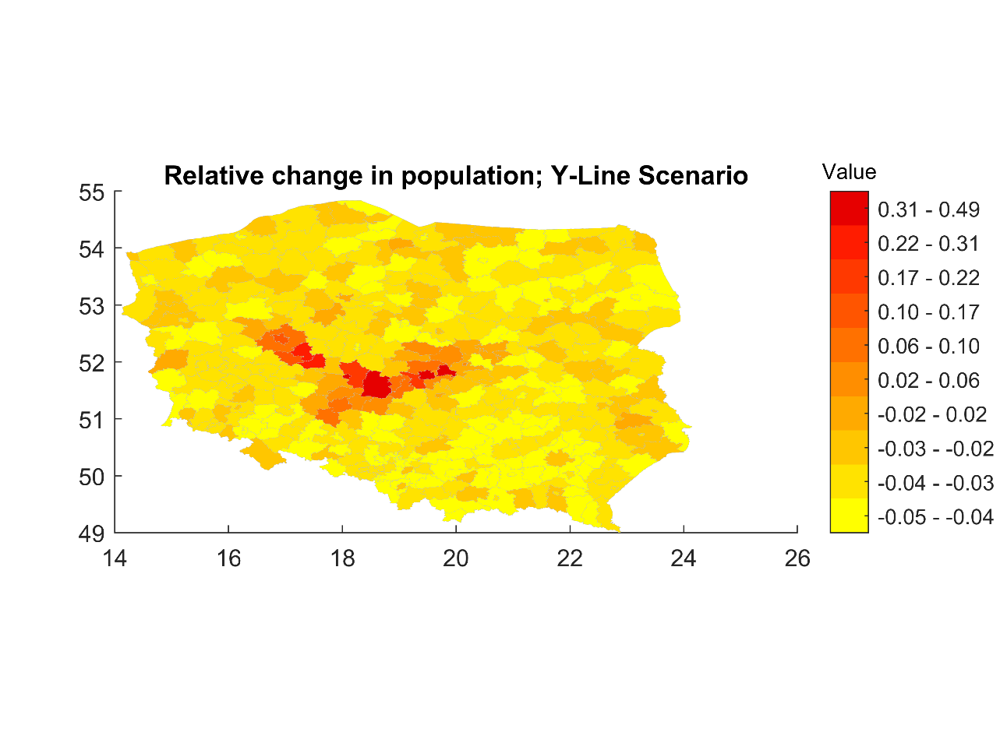

*Figure 6. Estimated relative change in population by county in the Y-Line Scenario*

The areas around the line will be much better connected, and thanks to this, the inflowing inhabitants will gain better wages opportunities, which will raise the average wages in counties along the Y-line. The wages around Poznan will, however, experience a dump. The inhabitants of the areas surrounding Poznan will accept lower wages with roughly the same tradeable goods and house prices in exchange for significantly improved commuting access.

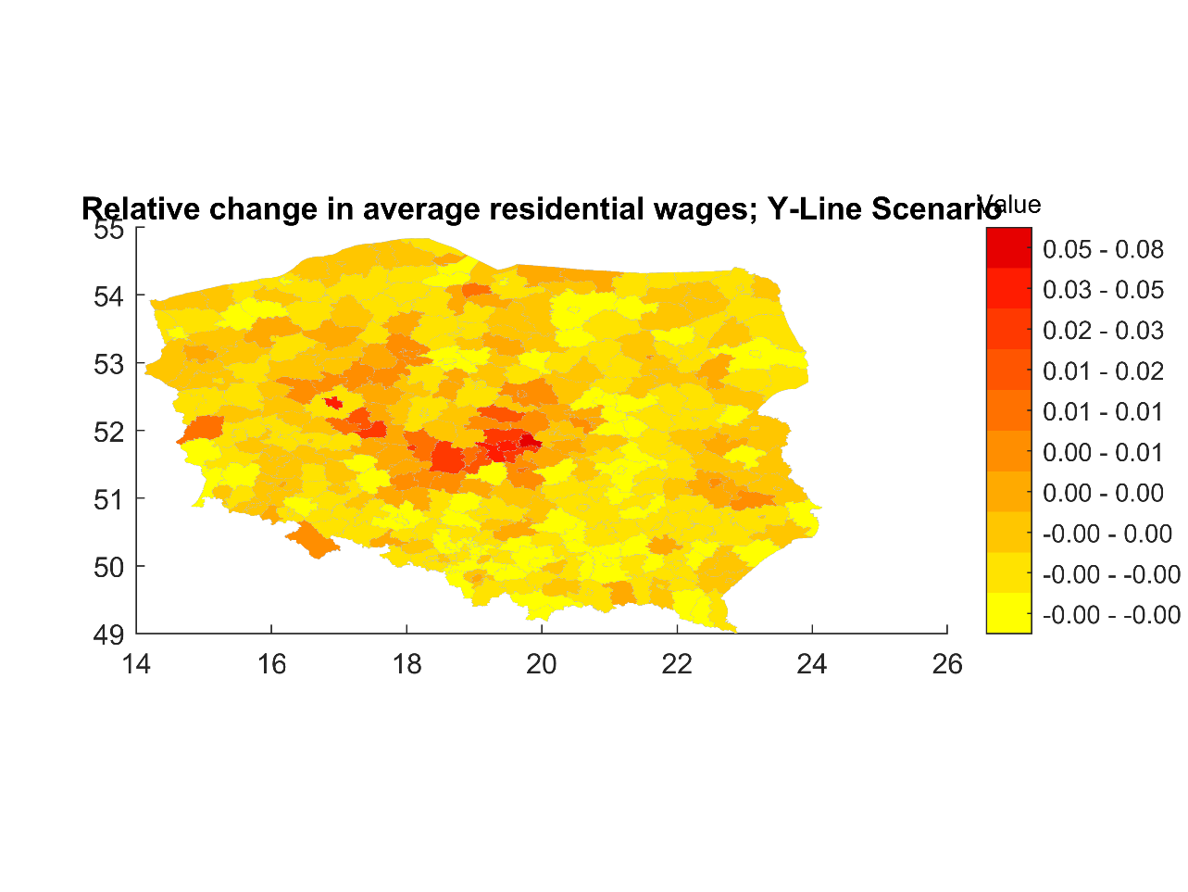

*Figure 7. Estimated relative change in residential wages by county in the Y-Line Scenario*

The investment will have a significant impact on the house prices along the Y-Line. The significantly lowered commuting costs will decidedly increase the demand for the properties and so their prices.

*Figure 8. Estimated relative change in house prices by county in the Y-Line Scenario*

A small change of tradable goods prices in the counties along the line will occur, with a significant shift of the goods prices in Poznan – where the rise in population and wages will be overshadowed by an even greater rise in the share of expenditure on the local goods. It is important to remind that in the considerations in this article it is assumed that the cost of trade in goods do not change, and so they cannot have impact on the goods’s prices.

The total impact of the investment will be very significant, and according to the model it will amount to a 4.02% increase in the Polish GDP, which is a very significant amount.

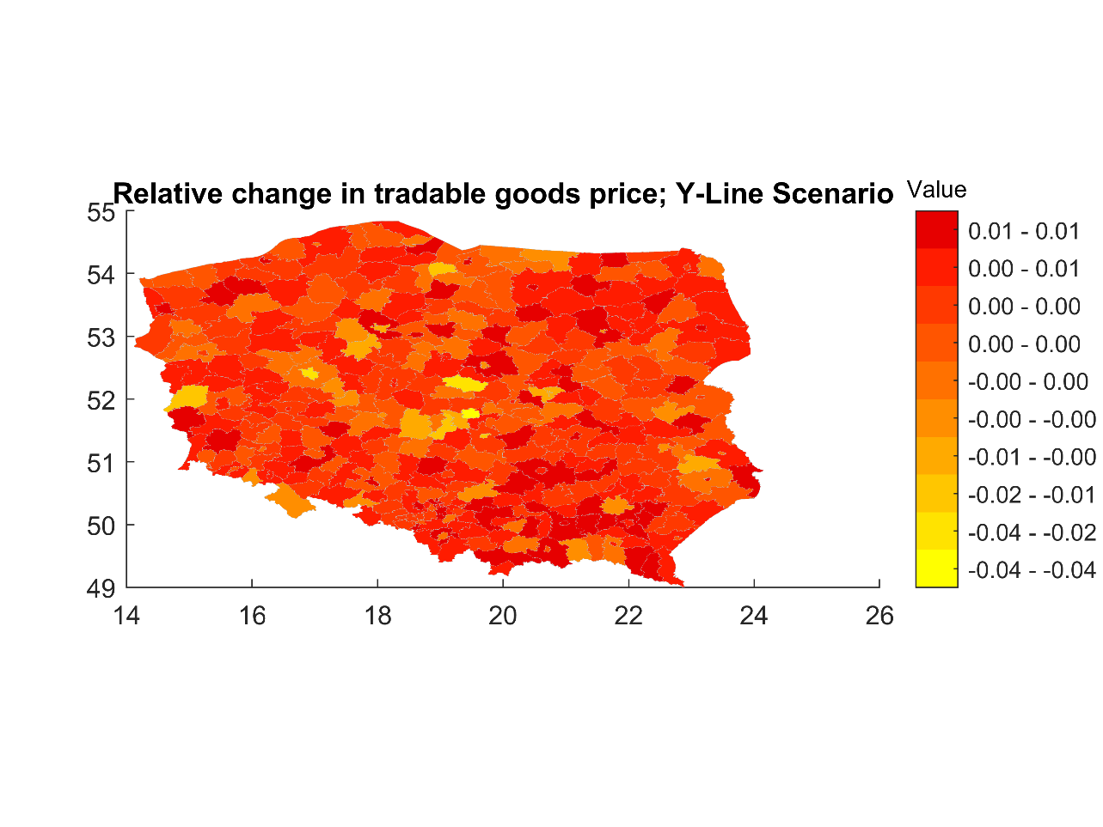

*Figure 9. Estimated relative change in tradeable goods prices by county in the Y-Line Scenario*

**4.b. The PIS “Spokes” Project**

By the analysis of the scenario it is important to keep in mind that the railway accessibility estimation approach I chose allows for the costless switches between train lines, while commuting from place to place. This assumption is unrealistic and especially in the PIS “Spokes” scenario may lead to to some extent biased outcomes, as almost whole Poland is covered with a new network of highspeed train. Nevertheless, it seems that the approach is sufficient to yield satisfactory estimations that I discuss below.

The realization of the PIS project would cause significant reorganizations in almost the whole Poland. Complete reorganization of the Polish railway network would result in the long-run movements of population reaching even several dozens of percents. Areas poorly connected with the railway network such as north-western parts of Poland would gain central access to the network. Areas poorer connected with the network would loose inhabitants on a big scale.

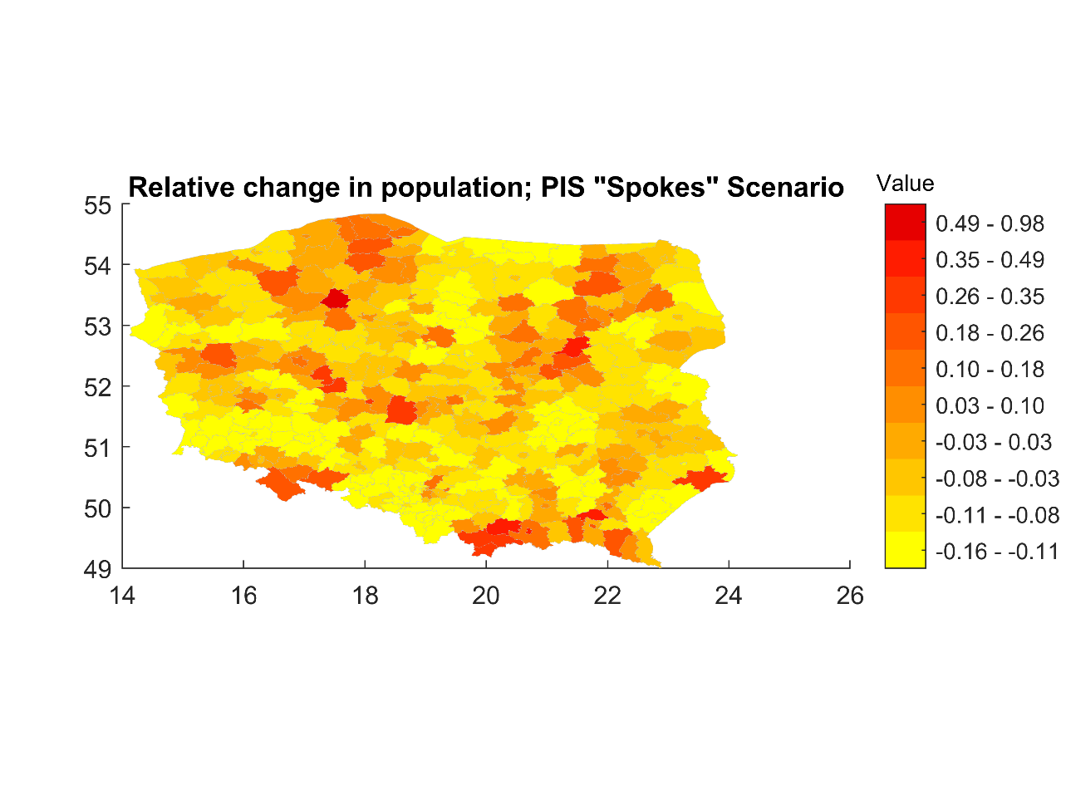

*Figure 10. Estimated relative change in population by county in the PIS “Spokes” Scenario*

The convergent shape of the network and its wide scope would lead to a significant boost of the wages of the residents of central Poland and areas along the Y-Line (component of the “Spokes”), whose job market access would significantly improve.

*Figure 11. Estimated relative change in residential wages by county in the PIS “Spokes” Scenario*

In the areas located along the railway lines, the significant rise in house prices driven mainly by the population inflow would recompensate the benefits of the improved commuting access.

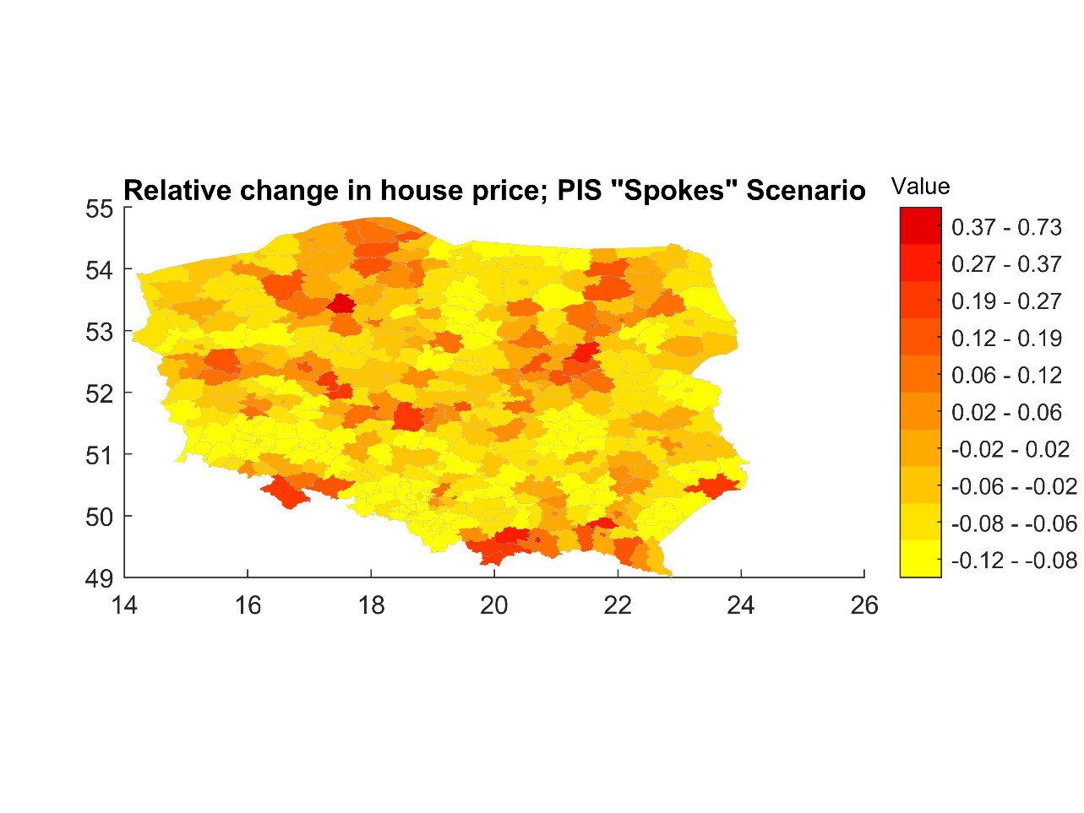

*Figure 12. Estimated relative change in house prices by county in the PIS “Spokes” Scenario*

The significant inflow of workers to Warsaw and Poznan reinforced by this construction scenario, together with rise the in wages in the both cities, would significantly increase the internal market in the cities due to much higher production and in result a significant *decrease* in prices. This result is however again dependent on the assumption that the development of the highspeed train network affects above all commuting costs, and not the costs of transport of traded goods. In total the investment would result in the increase of Polish GDP by 7.63%. Though it’s a very significant amount, it would demand a gigantic intervention in the existent railway infrastructure, and it seems that the results could be gained by a more reasonable use of the existent railway network. It is also spectacular, that the total returns from the giant investment would be not more than 2 times bigger than from the investment in the Y-line.

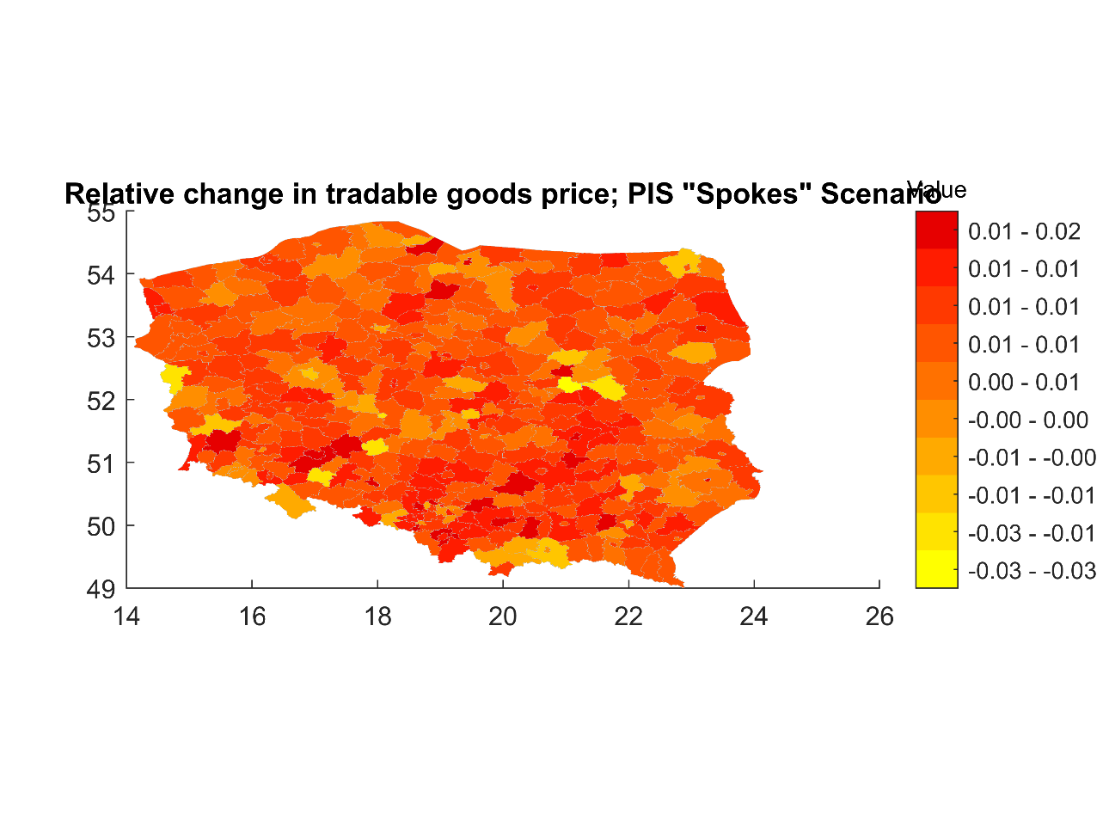

*Figure 13. Estimated relative change in tradeable goods prices by county in the Y-Line Scenario*

**4.c. The KO Project**

The closer integration of the KO project with the existent railway network and its seemingly more efficient use of planned railway paths make the impact of the investment much better traceable on the map. The extension of the Y-Line project to the north around the very Central Communication Port will result in a huge inflow of inhabitants to the areas in the central Poland along the line in the long run. The investment will reinforce the inflow of population to Warsaw, Łódź, Poznan and Wroclaw. It will significantly improve the connectivity of the southern parts of Poland, resulting in migration into that direction.

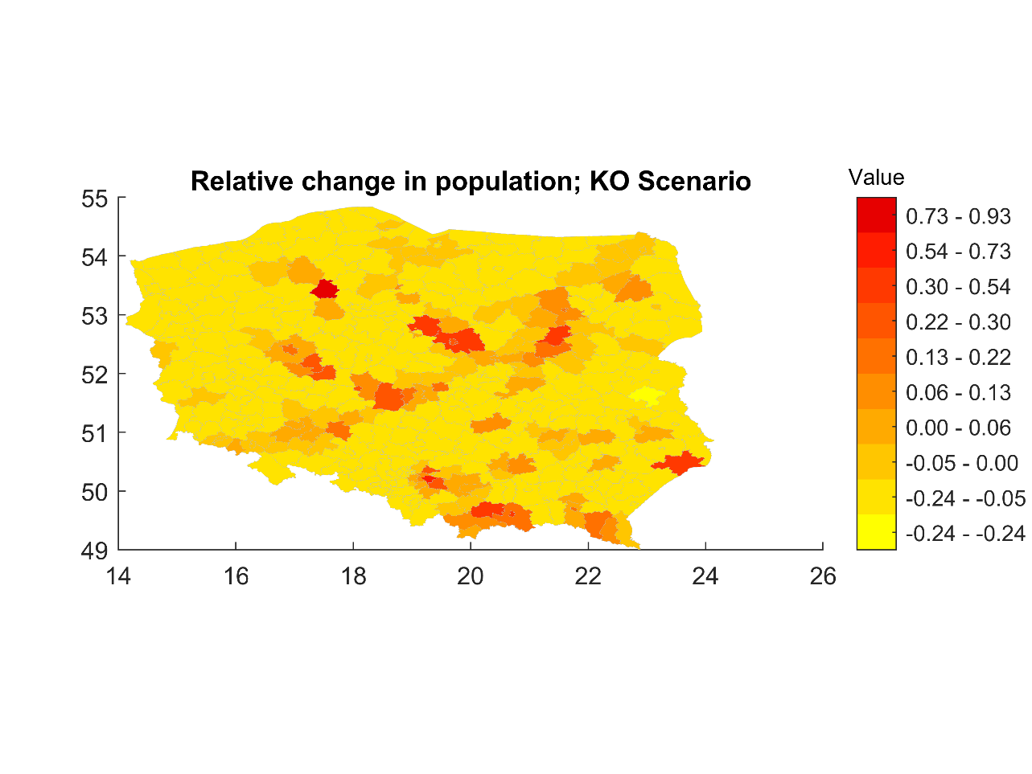

*Figure 14. Estimated relative change in population by county in the KO Scenario*

The increase in the wages will be again the most visible along the Y-Line, and along the railway to the north from the CPK. It will result from the better access to the job market in the places along the line.

*Figure 15. Estimated relative change in residential wages by county in the KO Scenario*

The areas along the railway will experience a rise in average house prices as the response to the inflow of population and the increase in wages. The increase in immobility prices will be especially prominent in Warsaw (gaining from even higher wages, better market access, and experiencing an inflow of workers), Łódź, Kraków, Wrocław and Poznań, and will be also noticeable again in the place of the split in the Y-line.

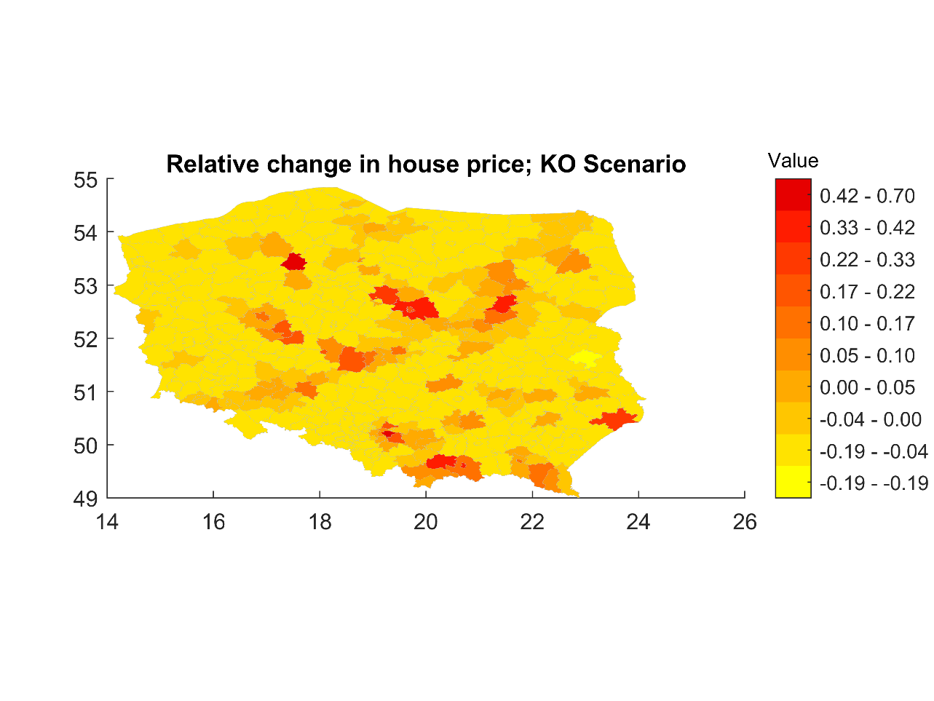

*Figure 16. Estimated relative change in house prices by county in the KO Scenario*

The change in tradable goods prices will be generally small, and unmatching to any bold geographic pattern.

In total, the much humbler investment within the KO Scenario will result in the growth of GDP equal to 5.48%, which is not such a significant amount in comparison with the gains from the Y-line investment alone.

*Figure 17. Estimated relative change in tradeable goods prices by county in the Y-Line Scenario*

**Conclusion**

The estimations presented in the model have to be of course taken with a pinch of salt, due to the tentative character of the analysis. It seems that the model would greatly gain from the integration with one of the developed transport model for Poland, such as the Integrated Transport Model. This direction promises probably the best field of further improvement of the above presented analyses. Already this simple model seems, however, sufficient to formulate some precise arguments to differentiate between the models.

In addition, the comparison of the three scenarios leads to some general conclusions about the impacts of the investments in railway. Firstly, it seems that the investment in the Y-line can be most easily justified, as it leads to the stunning increase in the Polish GDP of around 4%. It also leads to the most significant changes in the close neighborhood of the line and will probably have a significant impact on Warsaw, Poznan, Wroclaw and Łódź. Secondly, the impact of all the projects concentrates in bigger cities. All projects reinforce the inflow of citizens to the bigger cities, push up their wages and house prices.

It seems that the component of the railway network that can have the biggest impact is the line turning around CPK to the north. Its impact is best visible in the KO project. It is true, that the economic impact of the railway depends highly on the location and function of the railway. Nevertheless, it seems on the basis of the described model, that further development of the highspeed railway network may economically pay off, and is reasonable.

**Literature**

Ahlfeldt, G. M., Seidel, T. (2024): Toolkit for quantitative spatial models. <https://github.com/Ahlfeldt/MRRH2018-toolkit>

Central Statistical Office [Główny Urząd Statystyczny]. (2024). *Local Data Bank [Bank Danych Lokalnych]*. Główny Urząd Statystyczny. <https://bdl.stat.gov.pl/bdl/dane/podgrup/temat>

GeoFabrik. (2024). *poland-220101.osm.pbf* [Data set]. OpenStreetMap contributors. [https://download.geofabrik.de/europe/poland.html#](https://download.geofabrik.de/europe/poland.html)

GeoFabrik. (2024). *poland-latest.osm.pbf* [Data set]. OpenStreetMap contributors. <https://download.geofabrik.de/europe/poland.html>

Heidelberg Institute for Geoinformation Technology. (2024). *Ohsome* [Software]. <https://heigit.org/big-spatial-data-analytics-en/ohsome/>

Monte, F., Redding, S. J., & Rossi-Hansberg, E. (2018). Commuting, migration, and local employment elasticities. *American Economic Review*, *108*(12), 3855–3890. <https://doi.org/10.1257/aer.20151507>

Sedlak & Sedlak. (2021). *Ogólnopolskie Badanie Wynagrodzeń [National Salary Survey].* <https://wynagrodzenia.pl/artykul/podsumowanie-ogolnopolskiego-badania-wynagrodzen-w-2020-roku>

Urząd Transportu Kolejowego. (2024, August 28). *Jaka jest średnia prędkość pociągów pasażerskich w Polsce?* Rynek Kolejowy. <https://www.rynek-kolejowy.pl/wiadomosci/srednia-predkosc-pociagow-pasazerskich-120283.html>

**Appendix**

